1. <https://www.youtube.com/watch?v=gCHUGgcGV48&list=PL3cFiqLUjlYPGlWWszesTtdI3v0tcLe5E&index=2>
2. Text

   Description automatically generated
3. Let’s start with understanding about Market?
4. If we want to purchase something like Veg, Furniture, we go to market. Similarly, we go to **Stock Market** to purchase **shares** of a company.  
   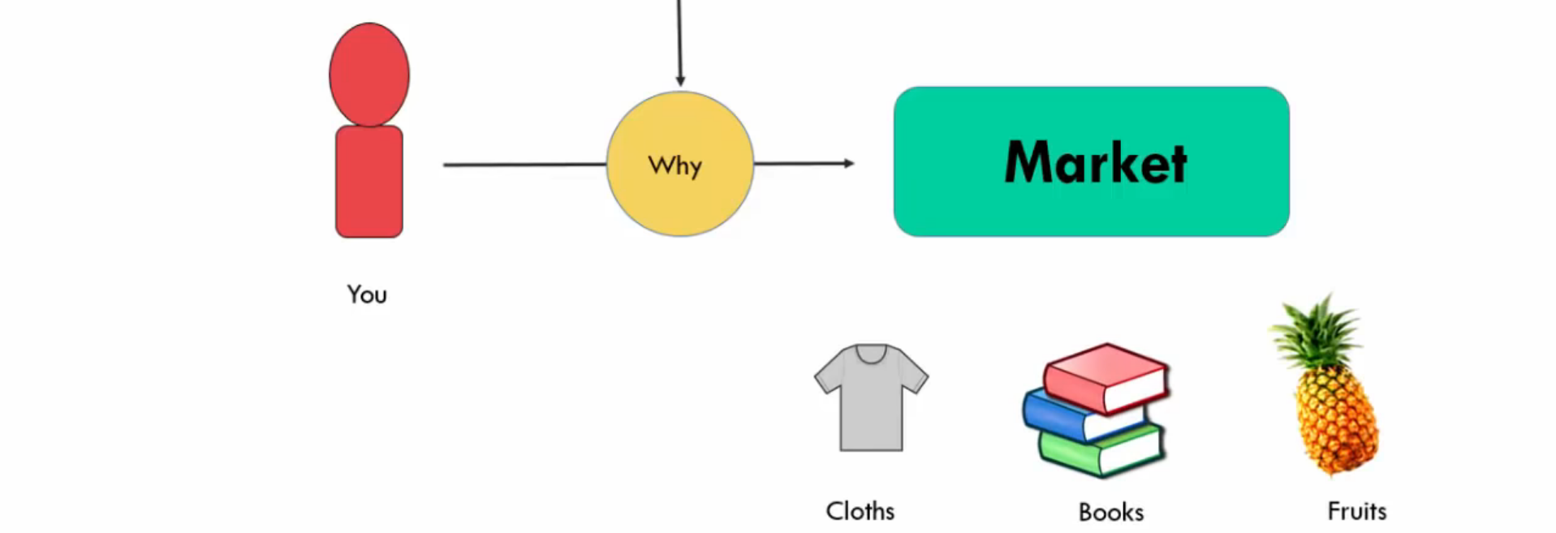  
   Diagram

   Description automatically generated  
   We don’t need to go to market to purchase shares as can purchase online.
5. **Shares VS. Stocks**:  
   Diagram

   Description automatically generated  
   Stock = A set of Shares.
6. Diagram

   Description automatically generated
   1. Stock Market helps to facilitate your transaction.  
      Like you have cash and want to purchase shares, or you have shares and wants to sell it.
7. A picture containing diagram

   Description automatically generated
   1. So, there are two Stock Exchanges in india.  
      Read next slide.
8. 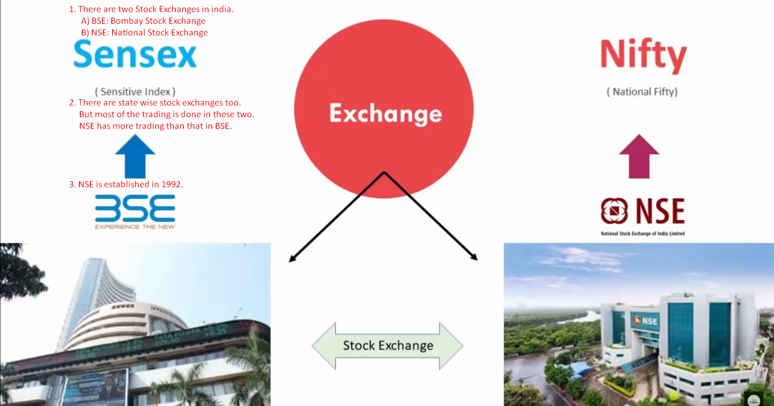
   1. **BSE** (Bombay Stock Exchange). It was 1st Stock Exchange of Asia.
   2. There are state wise Stock Exchange too but most of the trading is done in BSE, NSE.
   3. Most of the stock exchanges are done in BSE and NSE then b/w these two, NSE is most popular.
9. Now, we will talk about why a company releases his shares and why do you purchase them.
10. First we will talk about how to purchase shares of a company.
11. There are two ways to purchase shares of a company.
    1. Diagram

       Description automatically generated
    2. NSE/BSE provides the shares which are already purchased by someone else. So, they provide Secondary Shares.  
       That is why NSE/BSE is called **Secondary Market** as they provide shares already purchased by someone else.
    3. TCS, Infosys, Maruti Suzuki had already released their shares many years before so we can get from Secondary Market now.
12. Can we buy directly from Stock Exchange Website?  
    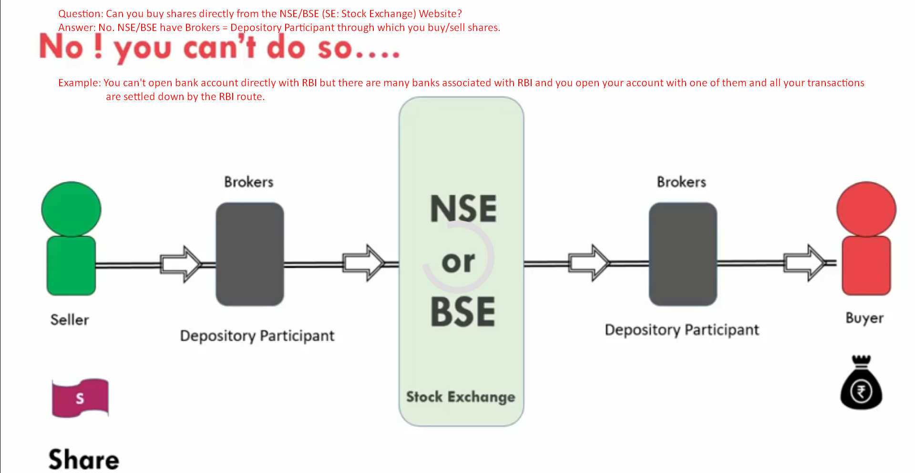  
    There are registered members to BSE/NSE and those are called 🡺 **Depository Participants** which are called **Brokers**.  
    So, to do any kind of trading (buying/selling shares) activities, you need to open account with a **Broker = Depository Participant**.  
    It is very similar to Bank.   
    If you want to open an account with RBI, you can’t do it directly with RBI but open with **public or private Banks** and further transactions are settled through **RBI Route**.   
    Similarly, any trading will go to NSE/BSE through Broker (**Depository Participant**) and settlement will be done by **NSE/BSE**.
13. 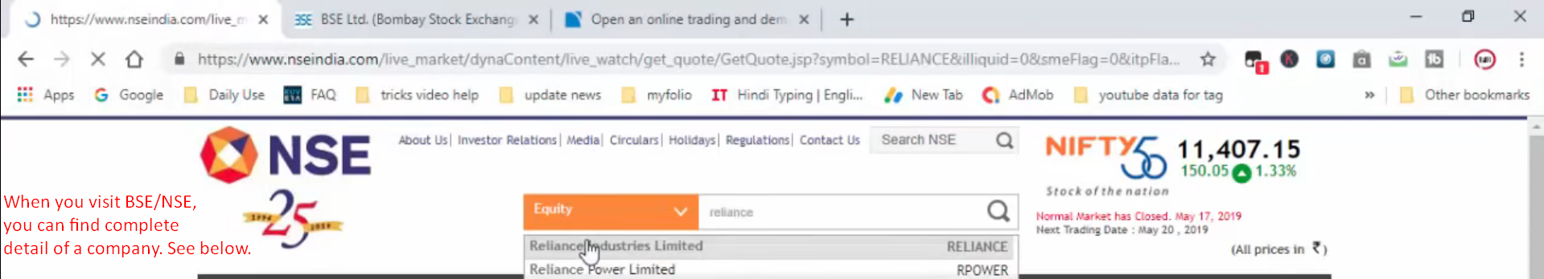
    1. Turnover.
    2. Market Capital.
    3. Share Price.
    4. Lot Size.
    5. Turn Over so far.
    6. Profit of a company.
    7. Who is the promoter?
14. Below you can see the website of a Broker (Depository Participant) where you can open your Demat Account.   
    